USE OF VIRTUAL REALITY TECHNOLOGY IN THE DIGITALIZATION PROCESS OF EDUCATION: FOUR MODEL MUSEUM

**Erol İ.1, Bayrak T.2, Yengin D.3**

*1 Istanbul Aydin University, (Turkey)*

*e-mail: iemreerol@aydin.edu.tr*

*2 Istanbul Aydin University, (Turkey)*

*e-mail: tbayrak@aydin.edu.tr*

*3 Istanbul Aydin University, (Turkey)*

*e-mail: denizyengin@aydin.edu.tr*

**Abstract**

Along with the developing technology and the social risks human faces, the society’s trends towards digital technology is inevitable. Undoubtedly, the interest of individuals in digital technologies has directly affected all sectors. The transformation of societies depending on their technological needs and conveniences offered by technology has formed new supply-demand balances, and sectoral changes have occurred in line with the demands of the society that was formed by the supply-demand balance. From a sectoral point of view, communication and related technologies have also been affected by all these transformations. Major developments in communication technologies have also led to changes in all sub-disciplines that are dependent on it. These changes have been so great that it has become necessary to explain separately and academically each of them. As a new and spreading technology, virtual reality technology is considered as a new opportunity by means of its key concept definitions and the successful implementation of both communication and educational processes. Especially, considering the qualities of generation Z, and the fact that the education processes are for generation Z; the probability of success of an education process by using virtual reality technology can be expected to increase. In this context, a study named “Four Model Museum” was carried out within the body of Istanbul Aydın University Faculty of Communication, New Media Applications and Research Center, which uses virtual reality technology and targets Public Relations undergraduate students. Within the scope of the study, the curricula prepared for Public Relations students were examined and four Models in Public Relations, which were considered as suitable subjects, were selected. Scenarios were prepared in the context of selected topics and sound were recorded in recording studios of Istanbul Aydın University, department of Radio, Television, and Cinema. Adhering to the scenario, 3D models, coatings, and finally, virtual reality software were developed. In this study, the scenario and content of the virtual reality education software named "Four Model Museum" were examined and analyzed within the framework of communication science.

Keywords: Virtual reality, public relations, education, communication, technology.

**Introduction**

Throughout history, societies have produced technology and have been transformed accordingly. A similar transformation exists today as well. In the process of transition to the information society, many changes occur and affect daily life. The inducing power of these changes is the innovations brought by technology. Technological innovations, which emerge in response to the needs of society, bring social changes along with them. As a conclusion of this process, digital transformation has emerged (Kocaman-Karoğlu, Bal-Çetinkaya, & Çimşir, 2020, p. 147-184).

In the digitalization process, virtual reality technology emerges as a communication and media tool. As stated, in the future, virtual reality will be used as the basic technology in the field of education. Various people foresaw that especially with the increase in spread, hardware costs will decrease, and accessible content will become high qualified (Ferhat, 2016, p. 726). Situations that deeply affect the natural flow of life, such as the current pandemic, have strongly increased the use of digital technology in education processes. Digital technologies have already begun to be used intensively in many stages of education. While the spread of various online education platforms poses as an example for private enterprises, the fact that the Ministry of National Education has moved all education processes to online and distance education platforms during the pandemic is a public example of the digitalization of education. At this point, the correct adaptation of new communication or media tools to the current education curriculum and the realization of successful applications are the main concerns.

When we examine the history of virtual reality in education, surprisingly, it is seen that the process has lasted for over a hundred years. The best-known examples of the use of virtual reality in the field of education are flight simulators, and the first example of flight simulators with the present virtual reality technology is Furness' equipment called “Super Cockpit” (Furness, 1986, p. 63-65). Today, the use of virtual reality in education continues with the use of more advanced equipment. While studies such as Engage (URL - 1) and ClassVR (URL - 2) offer synchronous virtual classroom and virtual conference environments in education processes, there are also asynchronous virtual reality supported applications for the use of medical devices such as defibrillators (Özdemir, Çakmak, Yol, Özdemir, & Özdemir, 2020). Regardless of which discipline it focuses on, the greatest difficulty in virtual reality use is related to the production of content. In the literature reviews conducted, it has been observed that there is limited information on the production of virtual reality content. In addition, the use of virtual reality technologies in the field of education and the explanations of this virtual technology as a two-way communication tool in educational processes within the framework of communication science is important. In addition, the importance of the use of virtual reality technology in the field of education and its benefits enabling two-way communication in educational processes within the framework of communication science stands out. A virtual reality software named “Four Model Museum” was developed within the body of Istanbul Aydın University New Media Research Center VR Laboratories in 2020 (Erol, 2020). In this study, the development process of the software named "Four Model Museum" was represented with its stages and the final content was tried to be explained in the context of communication science.

**Virtual Reality as a New Communication Medium**

The “virtual reality” is a three-dimensional simulation model created by computers, which feels real and provides mutual communication with a dynamic environment. (Yengin and Bayrak, 2019: 302). Virtual reality, which is expressed as an environment with full participation (Yengin and Bayrak, 2017: 103), is not a new concept when examined in terms of its history. Regarding the history of virtual reality, different sources point to different dates. In some sources, virtual reality is based on conceptual explanations of Ivan Sutherland's “The Ultimate Display” (Gobbetti & Scateni, 1998, p. 1). In some other sources, it is based on the flight simulation named “super cockpit” by Furness, an employee of the United States Air Force in 1977 (Gürcan et al., 2017, p. 3). No matter what the base of the historical background is, virtual reality is described as a simulation model (Linowes, 2015, p. 2) that creates a realistic feeling in a dynamic environment and offers two-way communication to its user by virtue of the computer-based technologies (Bayraktar & Kaleli, 2007, p. 2). With this aspect, virtual reality technology emerges as a powerful communication tool.

As a virtual reality technology, a Head-Mounted Display / HMD, today known as a helmet display (Bayrak and Yengin, 2021: 71) is used in a wide range of fields from medicine to tourism (Kaleci, Tepe, & Tuzun, 2017, p. 670). Undoubtedly, the field of education has also taken its place in this list. With the advantages it provides, virtual reality can provide educational content to students in a variety of ways. The definition of virtual reality by many authorities includes the various ways to use the educational content to be delivered to the student. For example, HIT Laboratories (Human Interface Technology Laboratory) affiliated with Washington University defines virtual reality as follows; “*It is a three-dimensional computer simulation that provides sensory information (sight, sound, and/or others) to make you feel that you are in a place”*(URL-3). As seen in the definition, while the educational content is presented to the student, it can be felt that the student is in a suitable place for the educational content, while more realistic and fantastic methods can be applied through the power of the developed software and input and output devices called various sensors. In this way, the student can learn by having a more permanent experience.

The features of the use of virtual reality in education can be listed as follows (Çavaş, Huyugüzel Çavaş, & Taşkın Can, 2004, p. 110); Interaction: The interaction of the student with the objects in the virtual environment allows the objects to be examined. The concentration of the student: According to research; The access of students to the educational content in the virtual reality environment helps the student to fully focus and comprehend the subject. Narrative Flexibility: Educational studies carried out in a virtual reality environment have story-based flexibility. Experiential Gain: Students gain virtual experience by using the virtual environment. Importance Given to the Senses: The fact that virtual reality technology appeals to students' sense organs is an element that accelerates the educational process. For virtual reality technology to be used in the educational process, it is undoubtedly important to examine its tools. In this context, the tools that allow the use of virtual reality technology can be examined under three main topics.

Today, when it comes to virtual reality, the first tool that comes to mind is HMD devices, which can be described as head-mounted screens. The first examples trace back to 1961 (Sherman & Craig, 2003, p. 25). HMDs have increased in popularity and prevalence with the widespread use of mobile devices and the reach of devices such as Oculus Rift and HTC Vive to the final consumer (Linowes, 2015, p. 3). HMDs can be described as a headgear in which there is usually a separate screen for each eye (in some cases, there is only one screen), usually, there are headphones and motion-sensing sensors. HMDs aim to give the feeling that the user is in a virtual environment with a wired or wireless connection to a computer. (Çavaş, Huyugüzel Çavaş, & Taşkın Can, 2004, p. 111). However, these features are constantly evolving and changing in form.

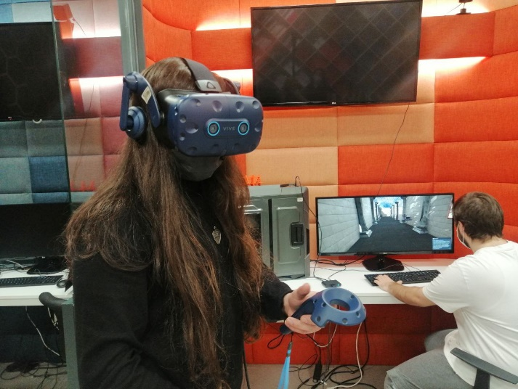

**Image 1:** An HMD and User (URL-4) Connected to a Computer

**Virtual Reality Simulator Examples**

Cabin simulators are virtual reality devices used to train the operators of vehicles such as airplanes, cars, and trains. They are mediums where education was carried out before expensive devices came into use (Şen & Satır, 2020, p. 17). Submarine Diving Simulator produced by Havelsan is a good example of cabin simulators. With the simulator, submarine personnel can be trained on the course of the submarine under and on the water (URL-5).

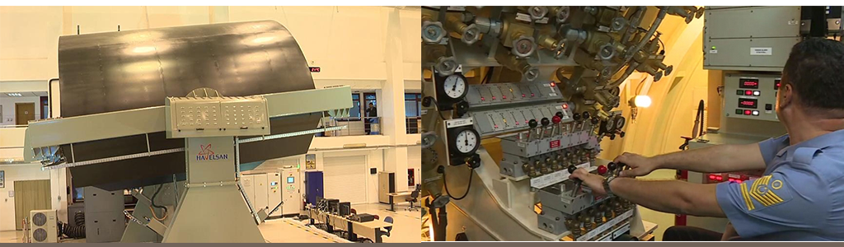

**Image 2:** Outside (Left) (URL-6) and Inside of a Submarine Diving Simulator (Right) (URL-7)

Room worlds are virtual reality tools used by projecting the image on all planes of the room in a way that more than one user can use. The first example of these rooms has taken its place in the literature as the CAVE system of the University of Illinois (McLellan, 1996, p. 467). In this technique, which is more dependent on desktop computers, the image is usually transmitted to the user via monitors, but the user can control the image presented on the monitor virtually with data glove or spaceball input tools (Çavaş, Huyugüzel Çavaş, & Taşkın Can, 2004, p. 112). In HCD, which is similar to the HMD structure but has qualitative differences, the user sees the virtual reality environment with the help of a suspended binocular-like device and experiences the control of the virtual reality environment with input devices connected to the computer (Çavaş, Huyugüzel Çavaş, & Taşkın Can, 2004). With the mirror worlds, the images of the users in the real world are transferred to the virtual world through display devices. This transferred image is processed with various technologies and presented to the user again. What distinguishes the mirror worlds from other virtual reality techniques is that the user does not have to use any tool (McLellan, 1996, p. 467).

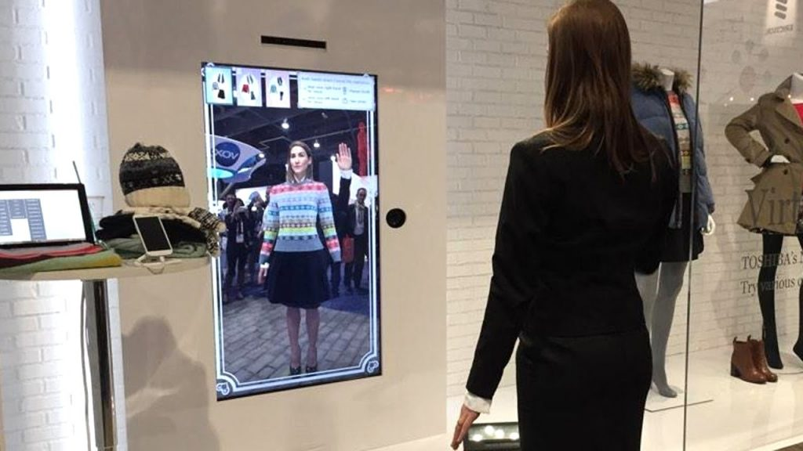

**Image 3:** Virtual Dressing Rooms Serving as an Application Example for the Mirror Worlds (URL-8)

**Four Model Museum Development Process**

The development processes of the virtual reality software called Four Model Museum consist of several stages and models. When the process is carefully examined, it is seen that it consists of three main topics. In addition, each title has its own sub-titles and processes. In this context, the primary stage, planning, refers to the section where the answers to some questions are sought and the project is designed in accordance with the schedule before making any development in the virtual environment for the project to be carried out. Therefore, when decided to develop the Four Model Museum, the planning process was carried out in two sub-stages: Theoretical Planning and Projecting.

**Figure 1:** Planning Model

In this section, which is called theoretical planning, the target to be reached has been determined and the existing problems have been identified in order to reach the target, and the tools necessary to cope with the identified problems have been determined. The problems identified at this point, in a sense, led to the formation of the sub-steps of the development, testing, and launch processes that took place after the planning process. In addition, the current capacity has been determined and solutions have been proposed for the issues outside the current capacity, and solution methods and alternative solution methods have been found. While making the theoretical planning for the Four Model Museums, the problems and solution suggestions given in the table below were determined.

**Table 1:** Problems and Solution Suggestions Regarding the Determination of Educational Topics

|  |  |  |  |
| --- | --- | --- | --- |
|  | Problem | Solution Proposal | Alternative Solution Proposal |
| Identifying Educational Topics | Selection of Educational Topics to be Presented in the Virtual Reality Environment | Receiving consultancy from an institution providing undergraduate education as it will target public relations undergraduate students. | Selection of topics by examining the printed materials related to the field of public relations higher education. |
| How to Present Educational Content | Presentation of the selected topics in a story-based manner with the help of a scenario to be prepared. | Gamification-based presentation of selected topics with the help of a scenario to be prepared. |

**Table 2:** Problems and Solution Suggestions Regarding Scripting and Sound/Music Topics

|  |  |  |  |
| --- | --- | --- | --- |
|  | Problem | Solution Proposal | Alternative Solution Proposal |
| Scripting | How the script to be written, and what it will serve (determination of qualifications) | The scenario to be written should be prepared in a structure with large space descriptions, including a synopsis. Depictions of places should be supportive of the 3D modeling process. |  |
| How to determine the elements that are outside of the textual structure in the scenario | After the script is written, the depiction of the place needs to be improved with a simple sketch based on the script. |  |
| Sounds and Music | How will the recording processes of the dialogs in the scenario be carried out? | Obtaining the necessary permissions for the use of the sound recording studio affiliated to the Radio, Television and Cinema Department of Istanbul Aydın University | Identifying and making agreements with private studios that provide the necessary qualifications for sound recording. |
| Determination of suitable music for the scenario and license problems | The use and supply of music not covered by the license on the Internet and is made available to everyone | Performing the music recording with the desired qualifications through musicians. |
| Where and how to source sound effects | Use and supply of sound effects that are not covered by a license on the Internet and are made available to everyone |  |

**Table 3:** Problem and Solution Suggestion for All Visual Content

|  |  |  |  |
| --- | --- | --- | --- |
|  | Problem | Solution Proposal | Alternative Solution Proposal |
| Visual and Textual Content | Where and how to obtain all visual/textual content within the scope of the scenario and licensing problems | Use of visual/textual content on the Internet that is accessible to everyone. |  |
| 3D Modeling | What are the objects to be 3D modeled? | A list of all objects in the scenario and all other objects that are not included in the scenario but will be used as decor in the virtual environment should be determined. |  |
| How will the virtual environment simulate the real world, regardless of the objects? | The sketch work carried out after the script writing should be taken as a reference. | If appropriate, a real space can be studied and modeled. |
| How will the modeling of the main and side characters determined in line with the scenario be realized? | Modeling service for the main characters must be purchased professionally. For side characters, licensed character models available on the Internet and suitable for reuse should be used. | All characters must use appropriately similar character models available on the Internet and be licensed for reuse. |
| Which software/tools will be used in the modeling processes? | 3Ds Max, Maya etc. 3D modeling software must be purchased and used under license. | The Blender 3D modeling tool, which is the free software of The Blender Foundation, should be used. |
| How will the Material and Texture operations, which are part of the modeling process, be executed? | Free materials and skins available on the Internet should be used. | Support should be sought from Istanbul Aydın University New Media students who are taking 3D Modeling. |
| Animation Recordings | How will animation recordings be executed for 3D models that require animation? | Blender software allows animation recording and blender software must be used. | Ready-made animations, which are a service of Adobe company and available on mixamo.com, should be used. |

**Table 4:** Problem and Solution Suggestions for Development, Testing and Launch Process

|  |  |  |  |
| --- | --- | --- | --- |
|  | Problem | Solution Proposal | Alternative Solution Proposal |
| Detection of Virtual Reality Platform | Which virtual reality device will be developed? | HTC Vive Pro | Oculus Rift S |
| Detection of Development Platform | On which platform will all the produced content be developed/converted to software? | Unreal Engine 4.xx | Unity 3D 2019.x.x |
| Test Process | How will it be determined that the software produced is working correctly? | Professional service should be obtained from software validation and testing companies. | The software should be tested in line with the test scenarios prepared based on the scenario. |
| Publish Process | Which distribution platform will be used? | The Steam platform must be used. | The appropriate one from Epic Store, Origin and other distribution platforms should be selected. |
| What are the solutions to be followed in case the distribution platform rejects the developed software? | The reasons for rejection should be investigated and, if possible, eliminated. Otherwise, launch processes should be carried out with other distribution platforms. | A special distribution platform should be developed for the developed software. Software should be released on websites etc. |

With the Project Planning process, which started after the theoretical planning, all the stages in the theoretical planning part were documented and scheduled. In addition, the determination of educational topics was carried out in this part, and it was decided to use the subjects named Four Models in Public Relations, which are included in the project in the curriculum of Public Relations undergraduate students. It has been seen that it is possible to present the selected topics with storytelling since they are more suitable for the story structure. In addition, other documentation processes (such as the preparation of the Model list) were carried out at this stage. The table below contains the calendar work for the Four Model Museum.

**Table 5:** Project Calendar

|  |  |  |  |  |  |  |  |  |  |  |  |  |  |  |  |  |  |  |  |  |  |  |  |  |
| --- | --- | --- | --- | --- | --- | --- | --- | --- | --- | --- | --- | --- | --- | --- | --- | --- | --- | --- | --- | --- | --- | --- | --- | --- |
| Work/Time | **2019** | | | | | | **2020** | | | | | | | | | | | | | | | | | |
| November | | | December | | | January | | | February | | | March | | | April | | | May | | | June | | |
| **Scenario** | x | x |  | |  |  | |  |  | |  |  | |  |  | |  |  | |  |  | |  |
| **Sound/Music** |  |  | x | |  |  | |  |  | |  |  | |  |  | |  |  | |  |  | |  |
| **Visual/Text Contents** |  | x | x | | x |  | |  |  | |  |  | |  |  | |  |  | |  |  | |  |
| **3D Modeling** |  |  |  | | x | x | | x | x | | x | x | | x | x | | x |  | |  |  | |  |
| **Development** |  |  |  | |  |  | |  |  | |  |  | |  |  | | x | x | |  |  | |  |
| **Test Process** |  |  |  | |  |  | |  |  | |  |  | |  |  | |  | x | | x |  | |  |
| **Launch Process** |  |  |  | |  |  | |  |  | |  |  | |  |  | |  |  | |  | x | |  |

The section passed after the planning phase is named the development phase. This stage includes the development of the software in every sense. The process from the realization of the sound recordings to the preparation of the software is considered as development phase. In the development phase of the Four Model Museums, the solution proposals for the problems determined during the planning were determined by making a situation assessment and the development process was carried out in line with these choices. If a different situation is encountered during the development process, it is aimed to make the selection again from the solution proposals determined during the planning stage, and to successfully conclude the project without any interruption.

**Figure 2:** Demonstrating the Pre-Model Development Process on the Model

Scripting is the most important stage of the whole project. The scenario is the ground and basis for the project to be developed. Therefore, the development phase started with scriptwriting. Scriptwriting has been carried out in a way that affects and supports the processes that follow. In the planning phase, although plans are mostly carried out against instrumental and external effects; the scenario allows the identification of software assets that will be used at any stage of the development phase, as well as the story to be presented. Since all assets subject to this project are intended to be produced as free of external dependence as possible, the scenario is wanted to be the guide during the realization of production. In this way, it has been ensured that no unanswered question remains at any stage of the development phase. In accordance with the French scenario format criteria, scenarios were written on the subjects determined within the framework of the educational content carried out during the planning phase, and dialogs and spatial descriptions were determined. Then, the sketch drawing, which is of great importance in the development process, was carried out. While creating the content of the sound recording process with the dialogues, the richness of the spatial descriptions had great significance in terms of modeling and sound effects, or stage placement.

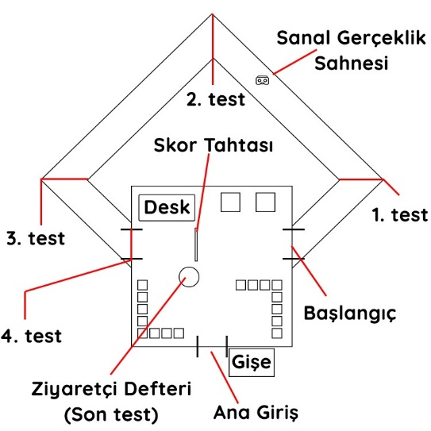

**Image 4:** Four Model Museum Layout Sketch

After the script work, permissions were obtained for the use of the Sound Recording Studio affiliated to the Istanbul Aydın University Radio, Television and Cinema Department to record the dialogs in the scenario. The sound was recorded by Serhat Yılmaz and İhsan Emre Erol, graduate students of Istanbul Aydın University.

metin, bilgisayar, masa içeren bir resim

Açıklama otomatik olarak oluşturuldu

**Image 5:** During the Sound Recording Process of the Four Model Museums

For sound effects, the scenario was examined and the ambiance and suitable sound effects for the conditions tried to be reflected in the scenario. The desired music to be used in the software was evaluated in terms of genre and included among the software assets by choosing among the licensed options from YouTube Music Library suitable for reuse.

The study carried out on the determination of the educational content during the planning phase created a draft structure for the determination of visual and textual content. Since the script was written based on the draft, the visuals, and textual backgrounds of all the objects in the scenario were prepared. To be used during the development, the digital versions of the images suitable for the scenario were determined by Google searches, and their license status was checked and saved for later use with the appropriate folder structure. Likewise, the texts to be associated with the images are recorded with appropriate folder structures.

metin içeren bir resim

Açıklama otomatik olarak oluşturuldu

**Image 6:** Visual and Textual Content from the Four Model Museums

**3D Modeling, Material/Texture Processes and Animation Recordings**

i. Modeling of Objects

The modeling of the objects mentioned in the planning phase and listed during the projecting phase started in this process. Some objects were modeled via Blender software, while some objects were obtained from the internet as licensed for reuse. From a frame to a flowerpot, these objects covered a wide range of items.

ii. Modeling of Virtual Environment

Based on the sketch in the scripting process and using the spatial descriptions determined in the scenario, the virtual environment called the Four Models Museum was modeled via Blender software.

**Figure 3:** Modeling Process Model

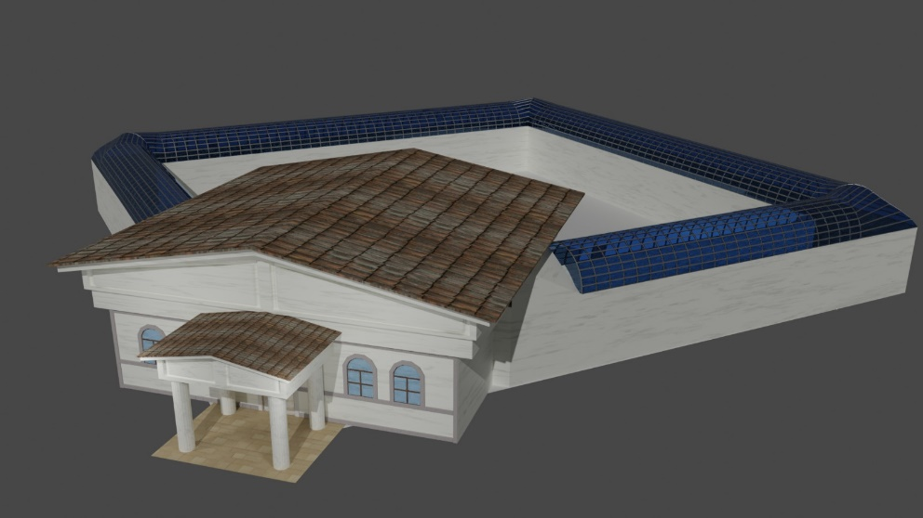

**Image 7:** Virtual Environment During Modeling

iii. Character Modeling

Character modeling stands out as one of the most challenging processes. Therefore, professional service was received for the main character in the scenario, and the side characters were chosen from among the free characters offered on mixamo.com, which is the service of Adobe.

kişi, adam, takım, giyinmiş içeren bir resim

Açıklama otomatik olarak oluşturuldu

**Image 8:** Characters Used in the Four Model Museums. Edward Bernays (Left), Ivy Lee (Middle), Example of Other Characters (Right)

iv. Editing Materials and Textures

Although material arrangements are considered as a separate area of expertise, the problem has been tried to be overcome by using as many textures as possible. Internet resources such as polyigon.com and texturehaven.com, which are platforms that share free texture files, were preferred for the selection of textures, which are also referred to as coatings. In addition, Batuhan Çulhaoğlu, a student of Istanbul Aydın University New Media and Communication Department, supported the project in the processes called texture painting. In this way, it is ensured that the image of the virtual environment is as close to the real image as possible.

v. Recording of Animations

For the recording of all animations, pre-made animations provided by Adobe company on mixamo.com were preferred. With this preference, it was aimed to speed up the process. Since Mixamo allows animation recording by loading 3D characters, the 3D main character, which is taken as a professional service, can be moved through mixamo.

vi.Software Development

During the software development process, the game engine named Unreal Engine, which was determined during the Planning phase, was used. All 3D models, sound recordings, and all other content prepared for this engine were included, software modules required for HTC Vive hardware were installed and necessary adjustments were made to run it in virtual reality mode, and software was developed using visual software development tools called Blueprint.

**Figure 4:** Demonstrating the Software Development Process on a Model

After the development of the software within the engine, the software was compiled for the Windows operating system and printed. All of the processes were carried out in the Virtual Reality Laboratories of Istanbul Aydın University New Media Applications and Research Center with the work of İhsan Emre Erol and Istanbul University Computer Engineering Student Oktay Şahin.

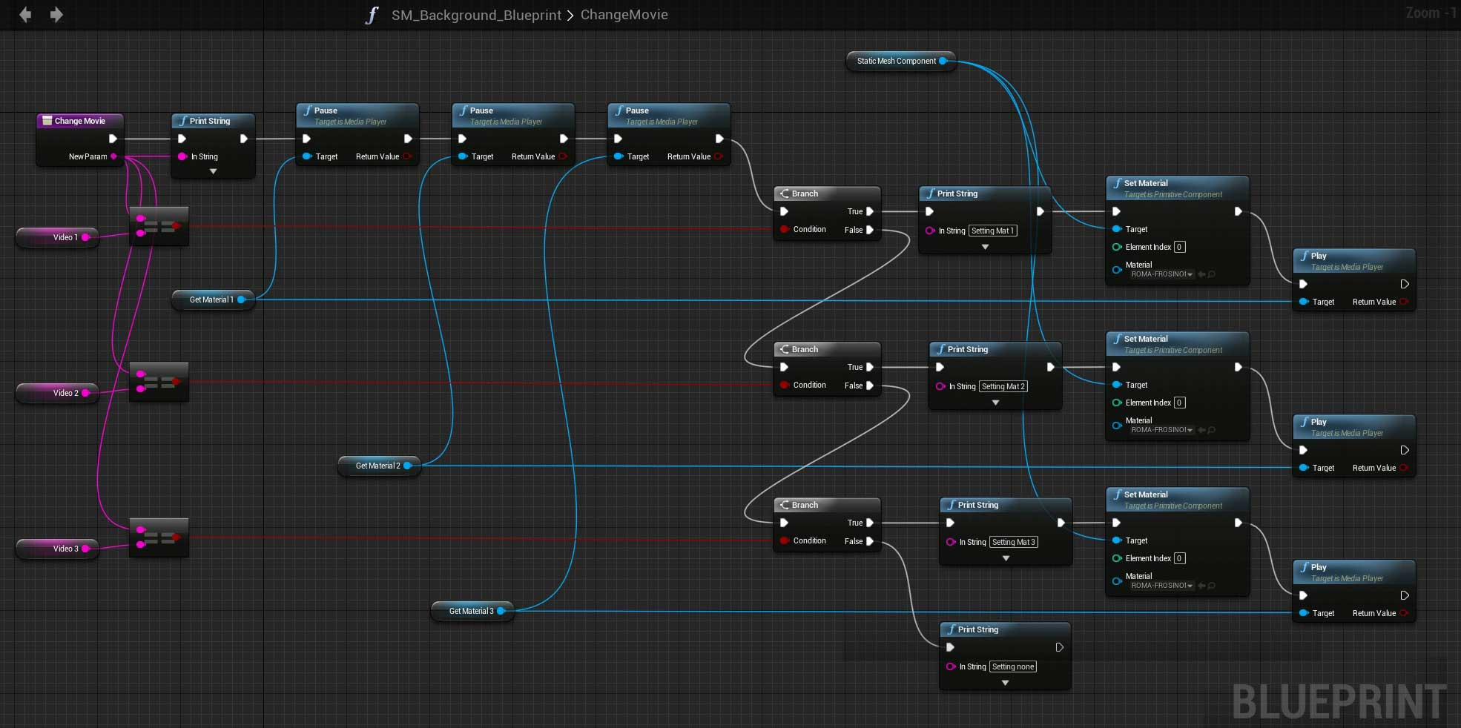

**Image 9:** Unreal Engine Blueprint Editor

The most important stage of any software development work is the testing process. The presentation of the software that works towards the user is naturally directly proportional to the success of the software. Contrary to popular belief, software development should actually be considered defect management work. However, the test processes to be carried out to detect errors are a very different process in relation to the depth of the project. The reason why the process is different is the cognitive barriers to the software developer's ability to test the software. The lack of information that is intended to be available between the developers and testers of any software increases the success of defect detection.

Based on this context, four model museum software were presented to the first use of university students and error detections were tried to be carried out. In line with the prepared test scenarios, the students were enabled to use every step of the software, and the feedback was received followingly. The testing process was carried out through a filter between the software development and the release process. The first software, which was printed for the Windows environment, was run in this process for testing and was converted into a test scenario with the addition of structures that did not exist before the scenario and can be counted as in-game interaction. Then, the test scenarios were applied on the running software and the error was detected and the report was created. With the generated report, the software was reintroduced into the software development process in order to upgrade the software version and eliminate errors.

**Figure 5:** Development, Testing and Release Process Model

This process continued until the software passed the test scenarios successfully, and as a result, a successful software has been prepared from the beginning to the end. The software, which passed the test scenario successfully, was put into the launch process.

In the past, the release of software was a process from packaging to sale, but today this situation has changed. Especially with the widespread use of the internet, software is now released over the internet. Along with the use of the Internet for publish, distribution platforms for software have begun to emerge on the Internet. Indeed, the best example of this today is the application stores on our phones. The Steam platform, which was prepared aim to serve this purpose, stands out as the distribution platform of digital games and game-like softwares that will run in the computer environment. The Steam platform, which was determined for the Four Model Museums during the planning phase, is the main environment where the publish processes take place and transactions were carried out through the web panels offered by the platform.

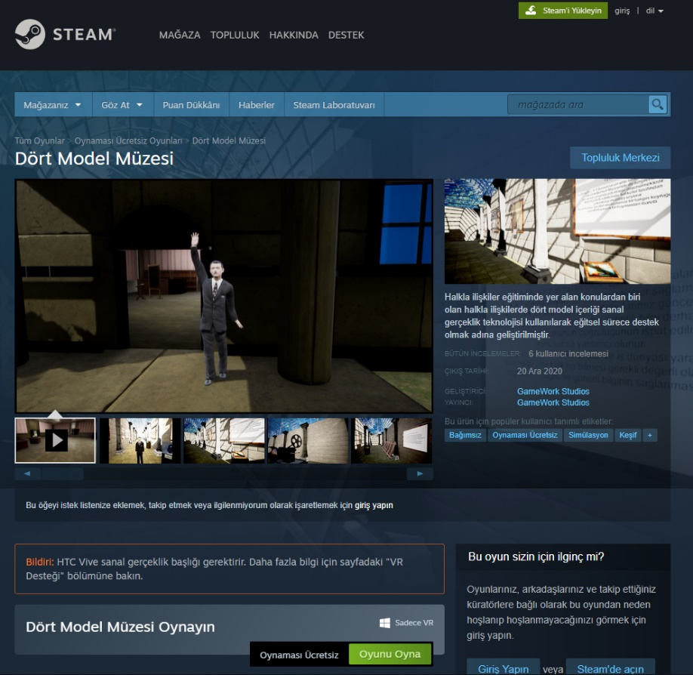

**Image 10:** A View from the Steam Platform Store Page of the Four Model Museums

The software, which has passed the testing process successfully, is available for publish on the Steam platform. The necessary accounts for the Steam platform have been created, the Steam platform's game publish agreements have been accepted, and access to the relevant panels has been provided. Then, the software was uploaded to the steam platform and visual and textual contents of the Four Model Museum were transferred via the panel. These transferred contents are requested by the platform to be used within the steam platform for the promotion of the Four Model Museum after the release. As a result of the examination of Steam officials, the Four Model Museum was published and opened to access on December 20th, 2020.

**Demonstrating the Whole Process with a Model**

Although the formation of the Four Model Museum until its release on Steam seems complicated, it actually consists of a sequential series of operations. If these processes are visualized and expressed with a model, they undoubtedly become more understandable and interpretable. In addition, when we consider the basic scope of the project, projects like the Four Models Museum actually include many different disciplines, from fine arts to communication sciences and physical sciences. The model also expresses the challenges of the project management for developing a digital product like the Four Model Museum. Although the Four Model Museums serve experimental purposes, and all assets aim to solve hypothetical problems internally, the emerging stages have revealed the necessity of carrying out similar projects with more than one individual. In reality, all the stages in the model represent a team.

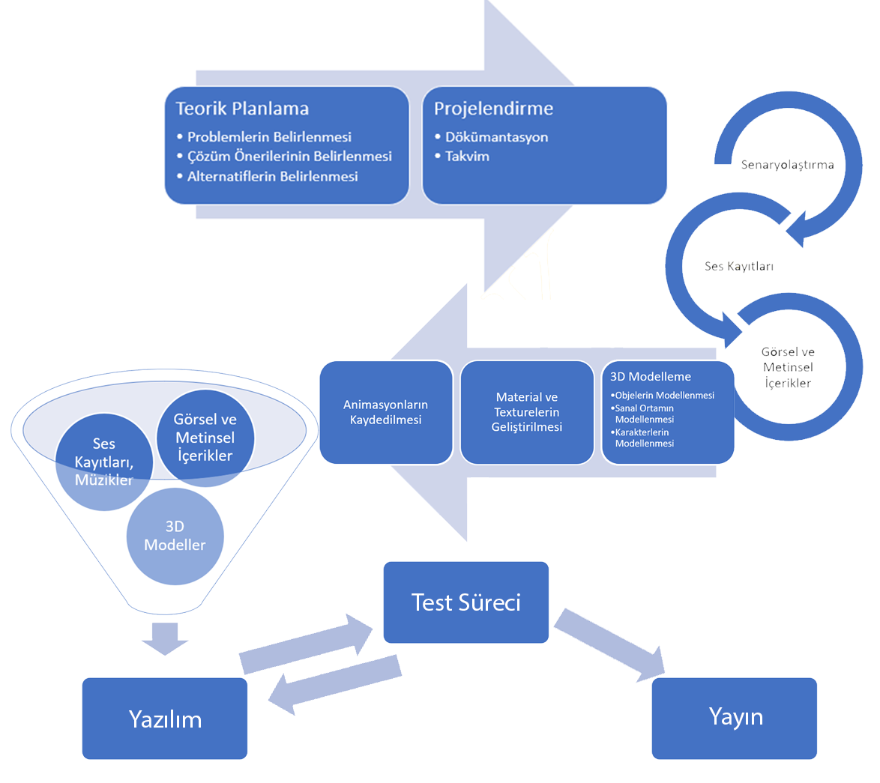

**Figure 6:** Demonstration of the Process of the Four Model Museum Software (from the planning process, until the release), on the Model

The determination of the problems that started with the theoretical planning and the solution suggestions were used as a response to all the situations encountered in the process, and besides, it was a pioneer in the healthy execution of the process until the last stage. In addition, the planning was documented and recorded in the project planning section and laid the groundwork for the creation of the project schedule. It is seen that the stages shown in Figure 15 are of generality that can be used in the execution of similar projects.

**Conclusion**

Virtual reality technology has a significant position among the rapidly developing new media technologies. The main reason behind this position is despite other technologies, virtual reality offers an innovative communication environment with various features. Virtual reality is called a full participation environment, which positions the user in a virtual world by isolating them from the physical environment. In addition, the user interacts with digitally designed objects in the virtual world within certain limitations. Virtual reality, which is a significant development in terms of the course of technology, is the harbinger of new communication environments free of wearable technologies such as holograms.  
  
 Virtual reality, which has started to be used in significant areas today, has started to attract intense attention after the Covid-19 pandemic. In this sense, virtual reality has become a solution for many issues such as education that directly concern social life and cannot be tolerated. When we examined the recent studies, it is clear that the focus is on how to get more benefits from this technology. In this context, from the data shared by digital platforms such as Steam, it is clear that intensive production progress is being carried out for virtual reality by many companies, which attracts the attention of new media technology and content producers.

The Four Model Museum, developed within the body of Istanbul Aydın University New Media Application and Research Center, was held to enable public relations undergraduate students to carry out their education with virtual reality technology, which is characterized as high technology. In addition, the theoretical knowledge and explanations that are frequently encountered in the field of social sciences are transferred to the field of practice. Thanks to this project, which includes social sciences as well as fine arts and physical sciences, it has provided a project development model on how the theoretical knowledge in the field of social sciences can be combined and presented with high technology in different projects. Besides this, it has also pointed out the required human resources. Based on the metaphor that ‘The only constant in life is change’, this project stated that social sciences, physical sciences, educational sciences, and other disciplines are parts that should not be separated from each other.

This study also set a good example that virtual reality and similar technologies can be used not only in educational processes for the field of entertainment and applied sciences but also in the expression of theoretical values that can be described as theoretical knowledge. Therefore, if it is evaluated in another sense, it has expanded the range of the use of virtual reality technology in terms of academic education. The use of the model applied during the conduct of the study -also being explained in this article- will increase the chances of success of the similar studies to be carried out, and will shorten the working time by providing solutions for all the problems that will be encountered before the actual implementation.

Undoubtedly, in the changing and developing world, there will be an increase in the number of studies to be conducted by blending all disciplines. High-tech tools developed for visual, auditory, and other human senses will take more place in the future in the social sciences discipline that examines humans and society, even if it is the field of physical science. Therefore, as expected, more human resources will be needed in the future and social and physical sciences will lead to the emergence of new disciplines, despite being partially intertwined.

**References**

1. Bayrak, T. & Yengin, D. (2021). Sanal Dünyada Yeni Şiddet. İstanbul: Der Yayınları.
2. Bayraktar, E., & Kaleli, F. (2007). Sanal Gerçeklik ve Uygulama Alanları. *Akademik Bilişim.* Kütahya: Dumlupınar Üniversitesi.
3. Çavaş, B., Huyugüzel Çavaş, P., & Taşkın Can, B. (2004). Eğitimde Sanal Gerçeklik. *The Turkish Online Journal of Educational Technology - TOJET, 3*(4), 110-116.
4. Erol, İ. (2020). *Halkla İlişkiler Eğitiminde Sanal Gerçeklik Üzerine Bir Araştırma.* İstanbul: T.C. İstanbul Aydın Üniversitesi, Lisansüstü Eğitim Enstitüsü.
5. Ferhat, S. (2016). Dijital Dünyanın Gerçekliği, Gerçek Dünyanın Sanallığı Bir Dijital Medya Ürünü Olarak Sanal Gerçeklik. *TRT Akademi, 1*(2), 724-746.
6. Furness, T. (1986, Aralık). Fantastic Voyage. *Popular Mechanics, 163*(12), 63-65.
7. Gobbetti, E., & Scateni, R. (1998). Virtual Reality: Past, present and future. *Studies in Health Technology and Informatics*(58), 3-20. doi:10.3233/978-1-60750-902-8-3
8. Gürcan, P., Coşkun, A., Sever, P., Başer, A., Ataizi, P., Öztürk, D., & Bical, A. (2017). Halkla İlişkiler ve Reklamcılık Eğitiminde Sanal Gerçeklik Uygulaması Kullanımı Üzerine Bir Değerlendirme. *İNİF - İnönü Üniversitesi İletişim Fakültesi Elektronik Dergisi, 2*(2), 2-15.
9. Kaleci, D., Tepe, T., & Tüzün, H. (2017). Üç Boyutlu Sanal Gerçeklik Ortamlarındaki Deneyimlere İlişkin Kullanıcı Görüşleri. *Türkiye Sosyal Araştırmalar Dergisi, 21*(3), 669-689.
10. Kocaman-Karoğlu, A., Bal-Çetinkaya, K., & Çimşir, E. (2020). Toplum 5.0 Sürecinde Türkiye'de Eğitimde Dijital Dönüşüm. *Üniversite Araştırmaları Dergisi, 3*(3), 147-158.
11. Linowes, J. (2015). *Unity Virtual Reality Projects.* Birmingham: Packt Publishing.
12. McLellan, H. (1996). Virtual Realities. D. Jonassen içinde, *Handbook of Research For Educational Communications And Technology* (s. 457-487). New York: Routledge.
13. Özdemir, H., Çakmak, B., Yol, Ş., Özdemir, H., & Özdemir, N. (2020). Sanal Gerçeklik Tabanlı Tıbbi Cihaz Eğitimi. *TIPTEKNO'20 Tıp Teknolojileri Kongresi*, (s. 404-407). İzmir.
14. Sherman, W., & Craig, A. (2003). *Understanding Virtual Reality: Interface, Application And Design.* San Francisco, CA: Morgan Kaufmann Publishers.
15. Şen, K., & Satır, O. (2020). Use of Virtual Reality Platforms in Design and Presentation. *International Journal of Scientific and Technological Research, 6*(11), 13-23.

**Electronic Resources**

1. URL-1 https://engagevr.io/ (Access Date: 03.02.2021)
2. URL-2 https://www.classvr.com/ (Access Date: 03.02.2021)
3. URL-3 http://www.hitl.washington.edu/projects/learning_center/pf/whatisvr.htm (Access Date : 20.03.2021)
4. URL-4 https://www.dha.com.tr/son-dakika/sanal-gerceklik-halkla-iliskiler-egitimine-de-girdi/haber-1808814 (Access Date: 20.03.2021)
5. URL-5 https://www.havelsan.com.tr/sektorler/egitim-ve-simulation/egitim-sistemleri/havelsan-deniz-platform-simulators (Access Date: 20.03.2021)
6. URL-6 https://www.aa.com.tr/tr/ekonomi/yerli-denizalti-dalis-simulatoru-donanmanin-hizmetinde/1362632 (Access Date: 20.03.2021)
7. URL-7 https://www.trthaber.com/haber/turkiye/yerli-uretim-denizalti-dalis-simulatoru-ilk-kez-trt-haberde-418858.html (Access Date: 20.03.2021)
8. URL-8 https://ardev.es/en/virtual-fitting-room-augmented-reality/ (Access Date: 20.03.2021)